Project #3: Chapter 12 Data and Statistics
Name
Institution
Date

Project #3: Chapter 12 Data and Statistics
Report I
- In had garden of 250 plants. The farmer grew 50 baby carrots using special soil. After maturity, he harvested them up and measured their lengths (to the nearest mm) and group the results:
Length (mm) | Frequency
150 - 154 | 5
155 - 159 | 2
160 - 164 | 6
165 - 169 | 8
170 - 174 | 9
175 - 179 | 11
180 - 184 | 6
185 - 189 | 3
- What is the population of this data set? What is the sample population? Is your data set an example of a simple random sample? Why or why not? If it is not, how could it have been collected differently in order to be a simple random sample?
This population of the data set is 250 plants. The sample population comprised of 50 carrots. The data set is not a simple random sample because the subset was not randomly selected from the larger set. To make it simple random sample, the study sample should be collected without influence of any other subject.
- Construct a frequency distribution and a histogram that includes a frequency polygon of your data. This can be hand drawn or done on software. Make sure that your axes are labeled, and your graph is titled on your histogram.

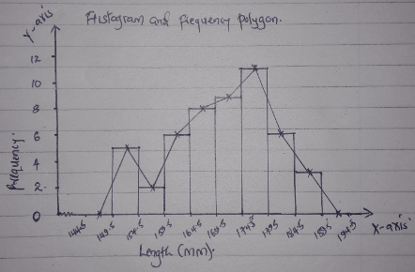
- Find the mean, median, mode, and midrange of your data set (you can use Excel/Desmos/online calculators to do this). Explain each measure of central tendency and why or why not you think it is a good representation of the data.
- Mean- it the central value of a discrete. Mean is a good representation of this data because it could be used to describe a set of data where the measures cluster or concentrate at a point.
Mean for this data can be calculated as follows:
Length (mm) | Upper limit  x | Frequency  f | fx
150 – 154 | 152.5 | 5 | 760
155 – 159 | 157.5 | 2 | 314
160 – 164 | 162.5 | 6 | 972
165 – 169 | 167.5 | 8 | 1336
170 – 174 | 172.5 | 9 | 1548
175 – 179 | 177.5 | 11 | 1947
180 – 184 | 182.5 | 6 | 1092
185 – 189 | 187.5 | 3 | 561
 | Totals: | 50 | 8530

Estimated Mean = 8530/50 = 170.6 mm
- Median – refers to the value separating the higher half from the lower half of a data sample. Median is a good representation in this data set because it will help in signing out the centralized value in a large data.
Estimated Median= 169.5 + (50/2) − 219 × 5
= 169.5 + 2.22 = 171.7 mm
- Mode- defines the most repeated variable in a data set. It is good in this data set because it will help in defining the most common values of the grouped data. The Modal group is the one with the highest frequency, which is 175 - 179:
Estimated Mode= 174.5 +11 − 9(11 − 9) + (11 − 6) × 5
= 174.5 + 1.42...
= 175.9 mm
- Midrange
The estimated midrange = (189-150)/2
= 19.2 mm
- Find the range of your data set. Explain what the range means in the case of your data and what it tells you about it.
Estimated range = 189-150 =39 mm. The range for the presented data is 39mm. It implies that the gap between the largest and the smallest values is 39 m and hence it gives information on the spread out of major observations are.
- Find the standard deviation of your data set (you can use Excel/Desmos/online calculators to do this). Interpret this standard deviation in relation to your data.
Estimated standard deviation:
Length (mm) | Midpoint  x | Frequency | fx | (x-x’)f
150 – 154 | 152 | 5 | 760 | 1729.8
155 – 159 | 157 | 2 | 314 | 369.92
160 – 164 | 162 | 6 | 972 | 443.76
165 – 169 | 167 | 8 | 1336 | 103.68
170 – 174 | 172 | 9 | 1548 | 17.64
175 – 179 | 177 | 11 | 1947 | 450.56
180 – 184 | 182 | 6 | 1092 | 779.76
185 – 189 | 187 | 3 | 561 | 806.88
 | Totals: | 50 | 8530 | 4,702

Estimated standard deviation: = ($√\frac{4702}{50}$)
sd= 9.7
The estimated standard deviation is small and hence it shows that the values in this set of data are close to the mean of the data set.

Report II
In Mapco School, the Mathematics teacher wanted to measure Intelligent Quotient of students in a class of 27 students in grade 12 level. The following table conveys sample data from data Maths score per student and the estimated IQ level. Let the Maths score per student be the predictor variable (X) and the IQ levels be the response variable (y).
Maths Score (percentage) | IQ  level
100 | 125
95 | 110
92 | 105
93 | 100
90 | 98
88 | 94
85 | 90
83 | 87
80 | 85
78 | 95
75 | 78
72 | 75
70 | 85
69 | 90
67 | 60
66 | 48
64 | 45
64 | 48
63 | 47
62 | 46
61 | 45
59 | 45
55 | 43
54 | 35
52 | 30

2. The identified data illustrates a positive correlation because the two variables (Maths score and the IQ level) more in the same direction. An increase in Maths score in percentage translated direct to an increase in IQ level.
3. 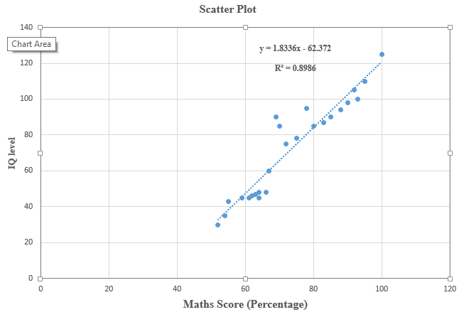

4. Equation of linear regression:
Y= 1.8336X – 62.372
5. The appears to be a positive correlation between the variables. The linear correlation coefficient is R²= 0.8986. The linear correlation coefficient indicates a strong, positive, linear relationship (Santolin & Saffran, 2018). As such, the Maths score per student is an ideal predictor of the intelligent quotient of that particular student.

Reference
Santolin, C., & Saffran, J. R. (2018). Constraints on statistical learning across species. Trends in Cognitive Sciences, 22(1), 52-63.

